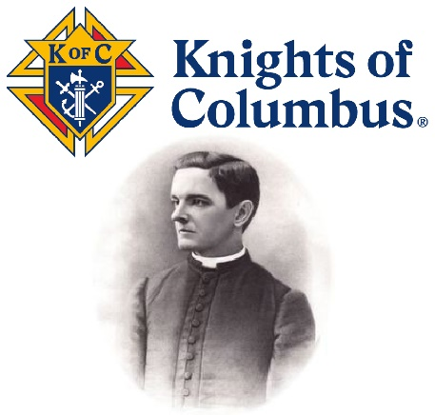
Father Michael J. McGivney’s Beatification
The Father of the Knights of Columbus

On Saturday, October 31, 2020 Father Michael J. McGivney, the founder of the Knights of Columbus will be one step closer to Sainthood as he is beatified through a special Mass in the Connecticut birthplace of the Knights of Columbus. As pastor of St. Mary’s Church in New Haven, this dedicated parish priest gathered men together in the basement of his Church to help save widows and children from destitution and defend the Catholic faith. Today these men we call Knights are over two million strong and are dedicated to serving Jesus Christ and their communities at home and around the world.

Won’t you consider becoming a Knight today?

A NOVENA FOR CANONIZATION
& A CALL TO ALL CATHOLIC MEN
Catholic Men from around the world will join together on the feast of St. John Paul II and begin praying a special Novena from October 22 through October 30. The intention of the Novena will be for Fr. McGivney’s canonization and for more Catholic men to join in the Knight’s fraternal mission to help carry the Cross of Christ out in the world. The Knights invite you to join our Order by speaking with a brother Knight or by signing up online today at:
www.kofc.org/joinus.

(A copy of the upcoming Novena can bedownloaded at www.kofc-tn.org)

